**WEEK 3**

#1Write a java program to add the two numbers.

**Program:**

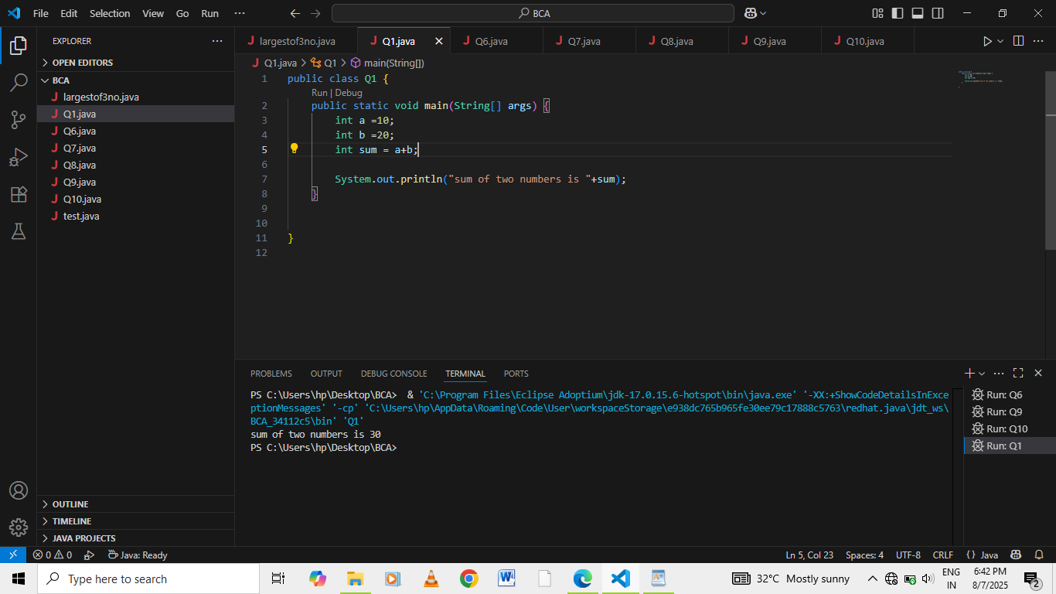

**Output:**



#2Write a java program to multiply two floating numbers.

**Program:**

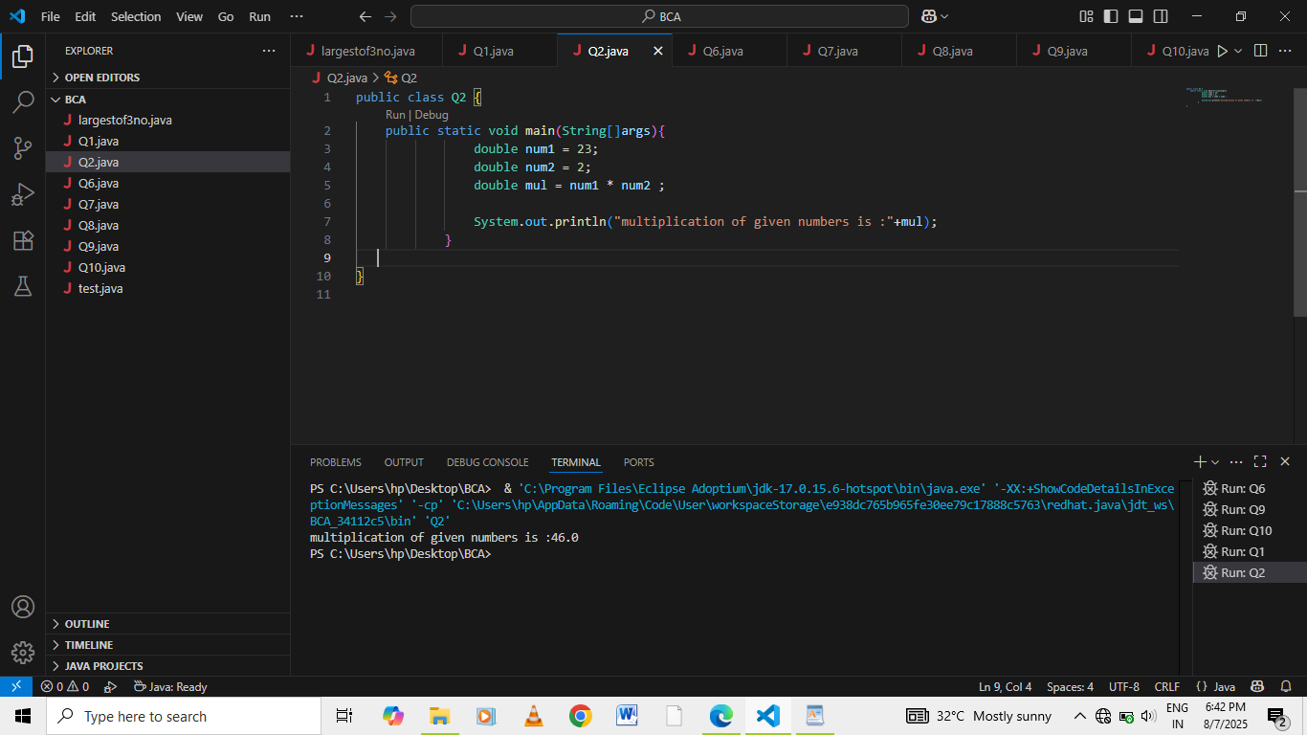

**Output:**



#3Write a java program to display a cube of a number .

**Program:**

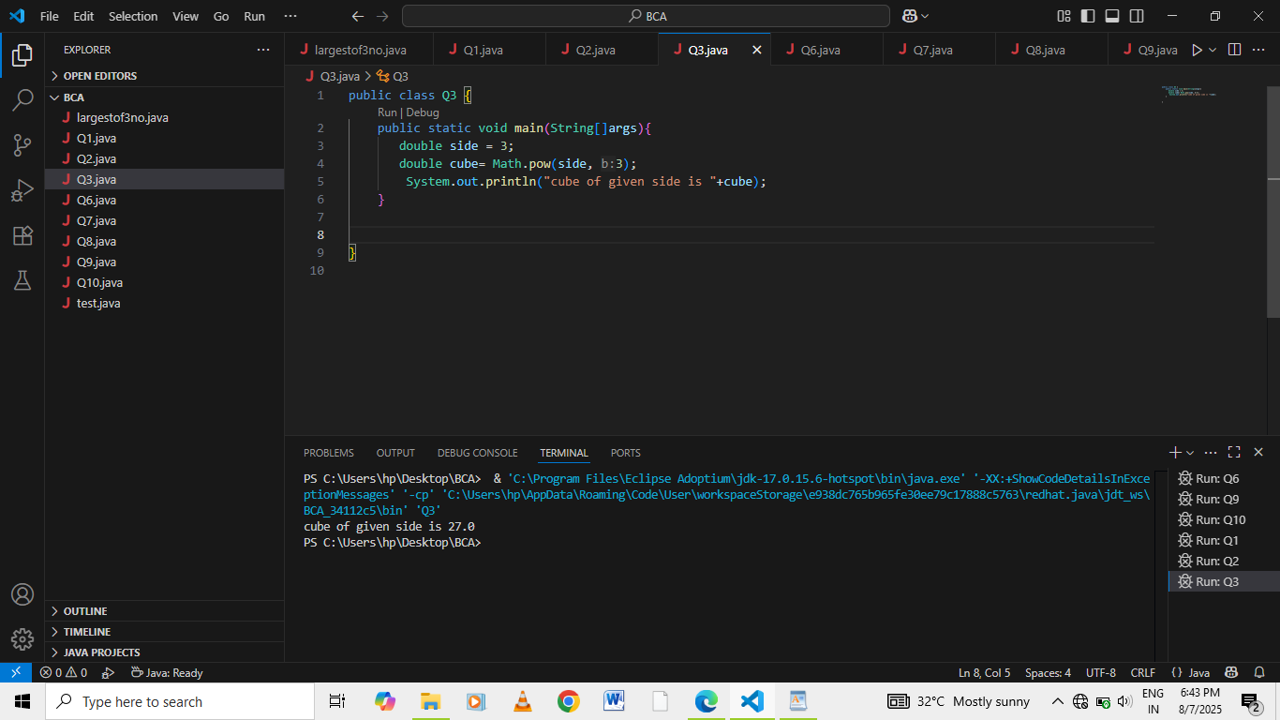

**Output:**



#4Write a Java program that takes three numbers as input to calculate and print

the average of the numbers.

**Program:**

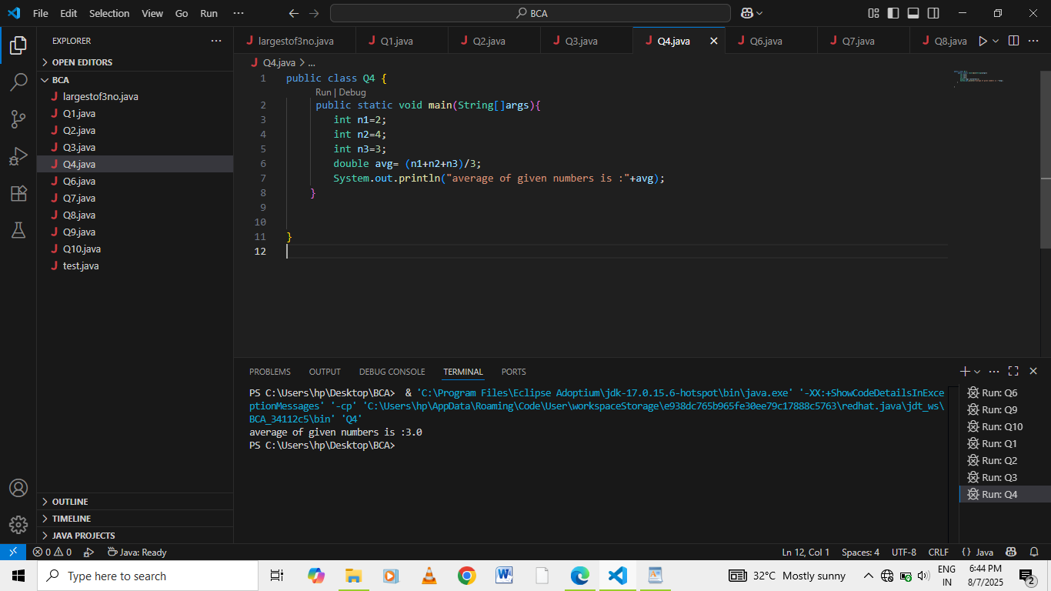

**Output:**



#5 Write a Java program to compute the distance between two points.

**Program:**

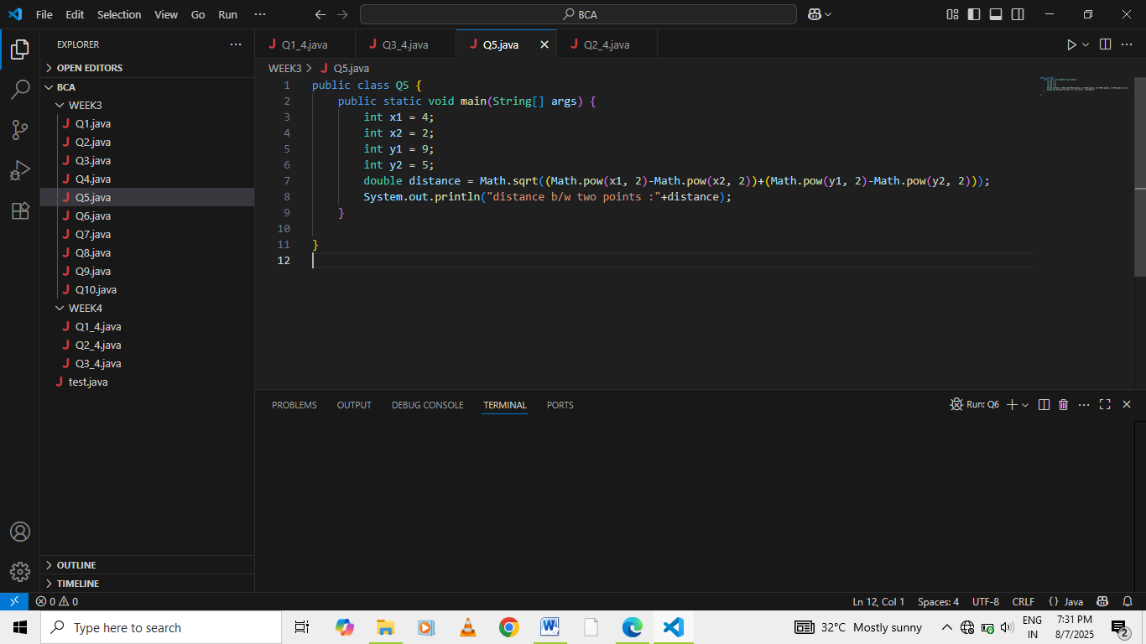

**Output:**

